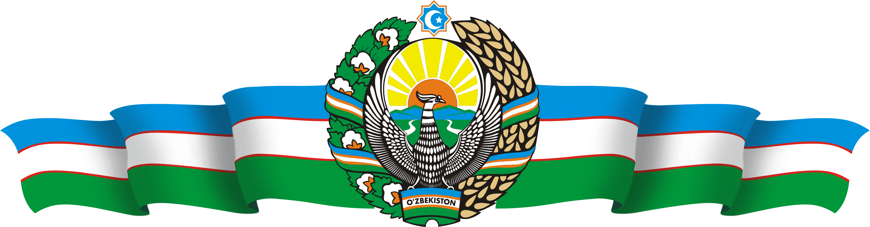

MINISTRY OF HIGHER EDUCATION, SCIENCE AND INNOVATIONS OF THE REPUBLIC OF UZBEKISTAN

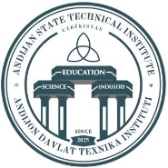

ANDIJAN STATE TECHNICAL INSTITUTE
INTERNATIONAL SCIENTIFIC-PRACTICAL CONFERENCE ON THE TOPIC:
“SCIENCE, INNOVATION AND ADVANCED TECHNOLOGIES: GLOBAL INTEGRATION AND INTERDISCIPLINARY SOLUTIONS”

INVITATION LETTER

Andijan – 2026

INVITATION LETTER
In accordance with Order No.11, dated January 16, 2026, issued by the Ministry of Higher Education, Science and Innovations of the Republic of Uzbekistan, and Appendix 1 thereof, concerning the “Plan of International Scientific and Scientific-Technical Events to be held in 2026,” an International Scientific-Technical Conference titled “Science, Innovation and Advanced Technologies: Global Integration and Interdisciplinary Solutions” will be held at the Andijan State Technical Institute from April 23rd to 25th, 2026.

Conference Directions (Sections):

The conference invites submissions for papers under the following sections:
- Prospects for Intellectual Automated Systems and Robot technics in Industry (Contact: A.A. Yusupov, +998979885664, https://t.me/Azizbek781).
- Automobile building and Transport Logistics: Challenges, Innovative Solutions and Development Prospects (Contacts: D.Moydinov, R.Dadaboyev, +998975831738, https://t.me/Dadaboyev_Ravshanbek; L.Bakirov, +998914913037 @lutfillo87; +998901406517 @PhD_AAI).
- Machinebuilding, Chemistry, and Light Industry: Manufacturing, Welding Processes, and Advanced Technologies (Contacts: Sh. Yoldashev, Oybek Sobitjon o’g’li Obidov, +998999005758 @AndDTI_DSc; G. Orazimbetova, Abduvoxid Muxammadamin o’g’li Mamirov, +998889995775 @mamirov_1313).
- Construction, Hydropower, Electric Power Engineering, and Alternative Energy Sources (Contacts:J.Usmonov, Kh.Askarov, https://t.me/+KOPGH5kdAug3OGNi, +998936317413; D.Karimjonov, Oybek Abdumannon o’g’li Qosimov, +998910066575, @Qosimov_O_A).
- Economics, Digital Transformation, and Innovation Management (Contact: I.Umarov, Shokirov Shohruhmirzo Baxtiyorjon o’g’li, +998948487757 shohruhmirzo_34_54).
- Metrology, Quality Management, and Sustainable Development in Environmental Protection (Contact: Sh.Sulaymonov, Ph.D. Kh.A.Vasiyev, +998936326717, https://t.me/mrVasievPhD).
- Social Sphere, Education, and Human Capital Development (Contacts: A.A. Khakimov, A.Q. Odilov, +998 90 621 15 13, https://t.me/Odilovazizillo95).

We invite professors, teachers, specialists, researchers, postgraduate students, talented students, and master’s students from universities across the Republic to participate in the scientific-technical conference. The program and collection of materials will be published before the start of the conference. The conference materials collection will be assigned a library classification number (UDC, LBC). Indexation will be performed based on the abstracts.

Working Languages of the Conference: Uzbek, Russian, and English.

Submission Requirements for Theses and Conference Materials:

Theses must be submitted via Telegram (in Word format). The file name must include the surname of the first author (e.g., “1-Qosimjonova Marjona.docx”). Submission of the Participant Application Form (request) is mandatory. The Abstract, Application Form (request), and Proof of Payment must be sent in a single “* zip” file (the zip file name must be the surname of the first author, e.g., “1-Qosimjonova Marjona”).

Materials must be formatted in Times New Roman, 14pt font, spanning 3–5 pages in A4 format, fully justified. Margins: Left - 2.0 cm, Right - 2.0 cm, Top - 2.0 cm, Bottom - 2.0 cm. Paragraph indentation must be 1.0 cm. Line spacing must be 1.5.

The title of the abstract must be centered and bolded. Skip the next line. From the subsequent line, write the Author’s Full Name, academic degree, and title. Below, without skipping a line, write the full name of the affiliated institution, city, and country. Skip the next line, and from the next line, write the body of the abstract.

References must be cited within the main text in the format [1] (see Sample).

Working Languages: Uzbek, Russian, and English. Submissions in the Uzbek language must be in the Latin script.

Organizational Fee: The fee is 70,000 UZS per submission.

No fee is charged from foreign participants and students.

Each participant may submit a maximum of 2 abstracts.

Abstracts that do not meet the requirements or involve plagiarism will not be accepted and will not be returned to the authors.

SAMPLE TEMPLATE
TITLE OF THE ABSTRACT

Author’s Full Name, Academic Degree, and Title
Full Name of Organization, City, Country

Main text of the abstract [1]

References
1. Author. Title of the Source. Place of Publication, Year of Publication.

Participant application form (requist) sample:
- Full Name (Surname, First Name): _________________________________
- Academic Degree and Title: ______________________________________
- Place of Work, Position: _________________________________________
- Conference Track Number (Section): _______________________________
- Title of the Theses: _____________________________________________
- Phone Number: ________________________________________________
- E-mail: _______________________________________________________

ATTENTION!
Abstracts, Application Forms, and Proof of Payment must be submitted by April 15, 2026 (on that day too). Submissions sent after the deadline will not be accepted.
The Organizing Committee has the right to select scientific materials for publication.
Only abstracts recommended for publication by the Editorial Board and for which the publication costs have been paid will be published.
The conference materials will be published in a printed collection and in electronic format, and the electronic versions will be sent to the authors.
Authors are responsible for the accuracy of the data, facts, and statistics presented in the abstracts.



