Doküman No | KBU -FRM-0233
Yayın Tarihi | 28/08/2023
Revizyon Tarihi | -
Revizyon No | 0

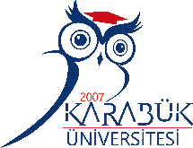

KARABUK UNIVERSITY
LETTER OF INVITATION

We hereby confirm that Karabuk University invites (STAFF NAME) from (UNIVERSITY NAME, COUNTRY) within the scope of Erasmus+ Staff Teaching Mobility Program from (…) till (...)
During her/his visit, she will lecture for (8 hours) at the (….) Department.

Date

Lect. Adnan UCUR
International Relations Coordinator

Karabuk University, International Relations Office, Rektörlük Binası C Blok 3. Kat Kılavuzlar Köyü Öte Karşı Üniversite Kampüsü 78050 Karabuk / TURKİYE
Tel:+90 370 418 8049 Fax:+90 370 418 94 07 e-mail: erasmus@karabuk.edu.tr

